Title
Forename Surname ^{1,*}, Forename Surname ² and Forename Surname ²
¹ IAMU member university, Country
² Second affiliation, Country
* Corresponding author: author@university.xx; Tel.: +00-00-000-0000.

Keywords: first keyword; second keyword; third keyword (three to five pertinent keywords should be listed)

These instructions provide authors with guidelines for abstracts for the 24th International Association of Maritime Universities Student submissions. Abstracts are limited to one page of text and 500 words. The abstract should clearly explain the content and relevance of the work. Authors must keep their camera-ready abstracts in the A4 paper size, Times New Roman font is strictly required, all margins, line spaces and text fonts are prescribed, and page numbers should not be added. Reference list style has to be the same as for the WMU Journal of Maritime Affairs (JoMA 2020). References have to be cited in the text by name and year in parentheses.
The theme of the IAMUS is “Protecting Our Mariners – Promoting Our Industry – Providing for the Future.” When submitting your abstract, please indicate one of the following categories in which the abstract will be registered and reviewed:
- Policy /Legal topics
- Economic/Trade topics
- Social/Cultural topics
- Technological /MET topics
- Environmental / Sustainability.

The abstract submission deadline is 4th of February 2024. Students should email their abstracts to bghosh@maritime.edu
Submission of an abstract will be taken to imply that it represents an original work and that it has not been previously published or considered elsewhere for publication. Please be aware that authors are responsible for the English language quality of the text. Notification of acceptance will be given by 20th of February, 2024.
The authors of selected abstracts will be invited to submit a full paper version by 4th of April, 2024. Instructions to prepare the full paper will be emailed together with the notification of the abstract acceptance. These papers will not be part of published conference proceedings. The accepted paper will be assigned by the Selection Committee for oral presentation at IAMUS.

References
International Hydrographic Organization (2017) Information on IHO standards related to ENC and ECDIS. Version 1.1. IHO, Monaco
WMU Journal of Maritime Affairs (JoMA) (2020) WMU Journal of Maritime Affairs, Submission guidelines. Springer Nature. https://www.springer.com/journal/13437/submission-guidelines. Accessed 3 March 2020
Svilicic B, Rudan I, Jugović A, Zec D (2019) Cyber security testing of shipboard chart radar. Proceedings of the International Association of Maritime Universities Conference, Tokyo, Japan, 129-134
Walling SA, Hill JC (2014) Elementary Marine Navigation. Cambridge University Press, Cambridge

Illustrations should contain only English labels and be prepared in the final published size, not oversized or undersized. Each illustration has to have a caption (Figure 1).
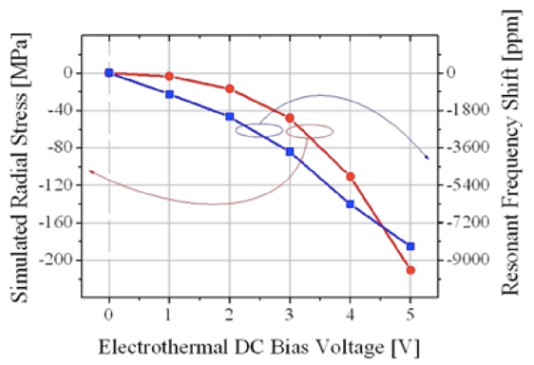
Figure 1. An example of a figure.

Tables have to be submitted as editable text and not as images. Each table has to have a caption (Table 1).
Table 1. An example of a table.
An example of a column heading | Column A | Column B
First entry | 1 | 2
Second entry | 3 | 4
Third entry | 5 | 6

Acknowledgements
If a funding has been provided for the research, please include brief information on the program or type of grants and awards.

